Practical Cybernetics: The Model and the Experiment

Choosing an Effective Model
A model is the best way to establish theory but the model must be carefully chosen to reflect the point of the research and the questions to be answered. This is not a static process and the model, if it is a good one, will teach the researcher more than only how clever he or she is. Dynamic models best serve these ends and ones found in nature are the most profound. Purveying the tool making abilities of the human form, we should choose a model where we can take the greatest advantage of this fact.
The best models are the ones most immediately accessible; household pets are excellent sources to glean analytical tools. Great care, however, must be exercised in the choice of model; it should be an independent agency with its own degree of observable intelligent behaviors but one that is not too dependent upon human intervention for success in adaptation. For this reason small pets and a common choice, the dog, will not be effective models. Small pets such as birds and fish do not display enough complexity—they can be reduced to ordinary differential equations—and the dog relies too much on the concept of the master to exhibit any useful behaviors. Therefore, the cat is the best choice. It has a range of characteristics and moods to provide subtle analytical tools, does not respond to any master in an ordinary sense, and one cat shares commonalities in behavior with others in its species. Additionally, cats can be reduced to a totality of visible behaviors. The model and its behaviors should be assessed as an invariant ethological core; at the beginning of the experiment the inherent behaviors should be charted and progress in discovering new manifest behaviors listed where applicable. So, let’s begin here.
Any cat could be a good model but obtaining a kitten is the best place to start. They are a “blank slate” as far as adaptive behaviors are concerned and can exhibit higher behaviors once accommodating to their surroundings. I chose a female shorthair Russian Blue simply for the beauty of the animal and because they are more intelligent than their subspecies counterparts. A female is an obvious choice; they tend to be more affectionate to human male companions and when spayed, only wander from the house in a radius no larger than 100 meters. Beginning here, let’s see what data is relevant to the model.
We want to glean our insights for the autonomous machine from the ethological routines of the animal. This means we want to observe and record the behaviors the animal exhibits so that they might aid us in our artificial designs. These routines will help to establish those necessary for an animae by example, the best method to employ to get intelligible and factual data.
I established my analysis by observing my cat for great lengths of time. Since I raised her from a kitten, she accepted me as a companion rather easily and was able to exhibit her own behaviors independent of what I thought they should or wanted them to be. Over a period of sixteen months, when she was about four years old, I was able to create a chart of her behaviors. The chart should be organized for clarity of thought and purpose, suggested to appear in the following form.
Subject Model Behaviors
It is relevant to study as many behaviors as allowed. Allow as many behaviors as the theory sees fit, you can reduce them to your experiment later. Include (as I have) those behaviors noted in texts or from other sources, they are just as relevant as what is directly observed. Build an abstract which details the discussion at hand and be sure to note where you are unsure as to the relevance of the data. Break each of the behaviors into groups, those which are the core or genetically programmed, adaptive or learned behaviors assayed from the environment, environmental concerns, and social behaviors when available. My cat has had limited exposure to other cats and the social dialogue can be left for more advanced studies. The chart should appear in the following format.
Details (Abstract):
The contents of this document belong to observed, subjective behaviors of my cat, Aggie. The goal of this is to put into proper context and form the ethological data gleaned from the process. The sticky part is how to compile and present the data in a useful and readable format to import the knowledge to the first animae. Therefore, by the time this document is completed, it will have gone through many revisions and reconfigurations. But I am confident this is the right step in the right direction.
Cats can memorize up to two syllables of any language if communicated as sing-song expression.
------Core Behaviors-------
Under this heading, core behaviors serve as an ethological baseline. Those listed here can be observed in other cats; subspecies designations are not necessary.
● Stretch front paws arching the back to greet attention
● Open doors with one front paw
● Sit in the window to observe activity in the outside world
● Hide for desire to be alone or to avoid conflict
● Chase moving objects such as insects, birds, animals smaller than the cat’s size and artificial ones such as string, yarn, or laser pointers
● Need for personal favorite toy (plush mouse)
● Request attention
● Demand attention
● General response given to “kitty-kitty” or other language variants such as “mew-mew” (French)
● Communicate affection by head butt
------Adaptive (or Unique) Behaviors-------
Under this heading are the behaviors learned as a condition of environmental pressures and social system between cat and favored human companion.
● Mew in response to vocal query
● Displaying anger or frustration when told cannot go outside (when living in one-room house-cabin Ogden, Utah, USA)
● “Knowing” sequence of upcoming events by talking to animal
● Know food schedule— when dry food will be given and when wet food (gravy) will be given. Additionally, she has learned to request food by a stream of meows and upon attending her, she seems to ask you to follow her into the bathroom (to her food area). When noticing and announcing she has no food, upon giving her food, she seems to react to validation of her request by performing her “happy dance” on the corner of the bidet.
● Travel
● Toilet/sink/tub observation (draining of water)
● Preference for stairs in living environment
● Playtime specifics
● Paper/plastic pawing on. Affectionately called “reading”. (Especially when working on available location to animal--like on the bed with a notebook). She observes the habit of writing and appears to watch intently for what it is I am doing and why I am so fascinated by the task
● Park—walk. Anticipation of time to go to the park and the appearance of a “good mood” upon returning. The “good mood” seems to last at least into the next day.
● Door jamb, corner dance play
● Peek-a-boo around corners, especially up/down stairs
● “Kisses” with nose to nose contact after handling considered annoying by animal
● Adaptation: Playing in the water that drips from the leaky sink faucet. After months of playing in the water and her understanding that water drips from the faucet, one dark morning while I was checking if the water was flowing with my hand (Aggie observing me) and upon finding no dripping, moving my hand to pat her head, she ducked away to anticipate my hand being wet
● --Painting—discovered in published book
● --Toilet training—discovered in online document
------Social Behaviors-------
● Accept other cats after time familiarity or after scolding
● Accept strangers who are friendly in animal’s opinion
● Like company when available—when lying/sitting on accessible location such as bed or lying on floor
Assaying the Environment
Aggie has lived in a variety of environments. I have lived in at least ten different places over the four years of her life. Perhaps this is a consequence of the times or of my lifestyle; regardless, many constants have run through. Her preference for certain aspects of the environments has changed little. She enjoys stairs and hiding around corners waiting for me to peek around them. When this play ensues, she runs down the stairs to me, her pupils wide and black, and chirps excitedly.
Although I have lived in many places, I find this apartment here in France quite unique. Aggie appears to enjoy her play much more here than in other places. To understand why this is, let me describe the apartment since the data I have gathered was done so in context with this particular environment. I have noted other behaviors from other places where they are relevant.
This apartment is a one-bedroom. It has a small kitchen (Room 1) about 4m² upon entrance and a set of stairs leading to an upstairs living area. To the right at the top of the stairs is a room (Room 2) about 6m² and to the left a bathroom (Room 3) about 8m². Room 1 serves as the kitchen. It has linoleum on the floor, a hybrid gas-electric stove on the northwest wall, a small ineffectual refrigerator, and a dual-basin sink. The spout is modern in design and plain chrome. To its right is a tiled counter area with cabinets above and a food storage closet at the far end. Near the front door just to the left of the stove is the door leading to a small hallway where another door leads to the street. To the left of the door is a small steam radiator. There are three types of wallpaper in room 1 and the front door is covered with its own unique style. Along the south wall is an open area with enough space to keep a small table. Currently, the area is vacant as the kitchen table serves as a work desk where I am writing this document. To the left of the area are the wooden stairs leading upstairs. There is a door with small panes of glass mounted to the stair exit. It even has a lock and its purpose escapes me.
Up the stairs are the other rooms 2 and 3. All the floors upstairs are made form slats of wood and it creaks in certain places. Room 2 serves as a bedroom. It has thin maroon carpet with nouveau pattern on the floor and furnished with a large armoire with an attached closet, a small desk, a coffee table, and a bed. There is a large window and metal shutter which faces north-west to a busy avenue. Traffic, notably trucks, whiz by at all hours of the day save the early hours of the morning and Sundays. Aggie is reluctant to jump on the sill when the window is open, the street is loud and intimidating even from the second story. In the corner next to the armoire is the kitchen table which is now being used as a desk. Here is my work area. Just behind me is a steam radiator which serves as a good source of heat during the colder months. The area is quite comfortable. Behind and to the right of me leads to Room 3, which is the bathroom. It has a similarly thin carpet, turquoise with a pink nouveau pattern and furnished with a large tub, sink, and bidet. There is a large window facing the backyard where the landlord has a garden, many fruit trees, and a reflecting pool with goldfish in it. On the horizon are other homes and a medieval church which chimes its bells on the hour, on Saturday evening, and early Sunday morning. The window has an automatic shutter controlled by a button near the light switch on the other side of the room. Along the east wall are three closets with magnetic closures where Aggie likes to spend her time, I catch her sleeping in them from time to time. Along the south wall is a sink, mirror, and small closet with drawers in situ. The sink surface is unlike those in America, this one is carpeted and has a padded space of about 0.5m². The sink fixture is a U-shaped spout with hot and cold knobs close to the neck. The drain has a stopper controlled by a lift just behind the spout. The bidet, just to the right of the sink area, has a carpeted box cover which slides over it when not in use. To the right of the bidet, along the west wall, is the tub. It is boxed in with a carpeted surface similar to the sink area. It has no curtain although a shower attachment and one has to sit in the tub to take a shower. The spout is chrome with the hot and cold knobs close and the shower attachment bears a striking resemblance to a phone on a chrome cord. The ceiling in both Room 2 and 3 is pitched at an angle of approximately 30° to 1/4 each side of the ceiling. This reflects the pitch of the roof. Between the bidet and the tub are a set of shelves and a small space where Aggie’s food and water are placed. Behind the shelves is a storage room, small and squat. There is a matching room on the east wall behind the closets where the water heater is. There is a mattress stored there and Aggie sometimes naps here when she desires privacy. Her toilet is also kept in this room.
During the warmer months, the window facing the back yard is open most of the day. Aggie will climb on the sill and observe the backyard at intervals. But since it has gotten colder and the window not opened, I have placed a chair to the window where Aggie now sits and does her observation. I note she is agreeable to compromise if the situation demands. There is a small toilet closet between Room 2 and Room 3; the door has been mounted at a crooked angle and drifts itself closed when opened. We never have used the bidet, it leaks and is a little strange to those of us who are not native to France. One more thing, there are 15 varieties of wallpaper in the apartment. Every surface, including the doors, ceilings, inside walls of closets and sink areas are covered with it. Even in the room with the water heater and the mattress, the walls here have wallpaper.
Try to describe every detail about the environment, even if they do not seem relevant at the time. The details may come into play during the experimental phase. Consider doors, windows, stairs, rooms, floors, beds, rugs, upholstering of surfaces, wallpaper, and fixtures as I have done. Once you have assayed the environment, you are ready to use the data in context with the model and prepare for experiment.
Consider the range of areas the cat has and can be exposed to. I have discovered my cat has a penchant for stairs, she enjoys playing peek-a-boo around up-downstairs corners. She enjoys running up and down them, to her the downstairs is a completely different realm from the living area which is upstairs. My French apartment is unique in its design but the variables of her preference have changed little. I had a set of stairs while in the States when I first noticed this.
Once this data is compiled, think of how the data plays out. Consider the exchange between yourself and your model. Communication plays a vital role in subsequent behaviors. I have discovered if communication is satisfied—she asks for food by sitting pretty and obtains the want—more complex behaviors become manifest, such as joy by exhibiting a playful dance between rooms. This method builds on itself and is quite handy when employing them in the experiment with the machine. Pay close attention to what the animal is asking of you and communicate on her terms; remember you cannot impose too much of your will upon a cat. If you insist too much, she will shrink away and your data will become contaminated and useless.
When satisfied with your data, place them into categories illustrated by Figure 4. Ethology in complex animals is enhanced by communication between entities. Picture the communication variables from both your and the animal’s point of view. Think of what is happening from her perspective, think of how she views herself in context with her environment. She may not be consciously aware of what her environment is, as you do, but do not underestimate her observational and emotional prowess. Cats have survived as a species for millions of years; we have lived together for at least a few thousand of those years. There is a line of thought that the companionship we enjoy has been introduced into their genetic structure and although it is a very short time in the scope of evolution-time, do not neglect to anticipate this information.
The data you have gathered by study of your model is now ready to be compiled. In the next section, I will demonstrate how the data can be charted to obtain the greatest usefulness of it. You want to begin by looking at the data as a whole—a paradigm. Create headings and a brief description of the data and the reason for it being contained in the section. This will aid in understanding how the data fits together. From there you can distill the behaviors into groups. Once distilled, it can be employed in designing the architecture of the machine.
Ethological Paradigm (Communication)
This section serves to create a charted paradigm of the observed behaviors of Aggie. This information serves as a dynamic list of her behaviors and the system of communication between herself and I.
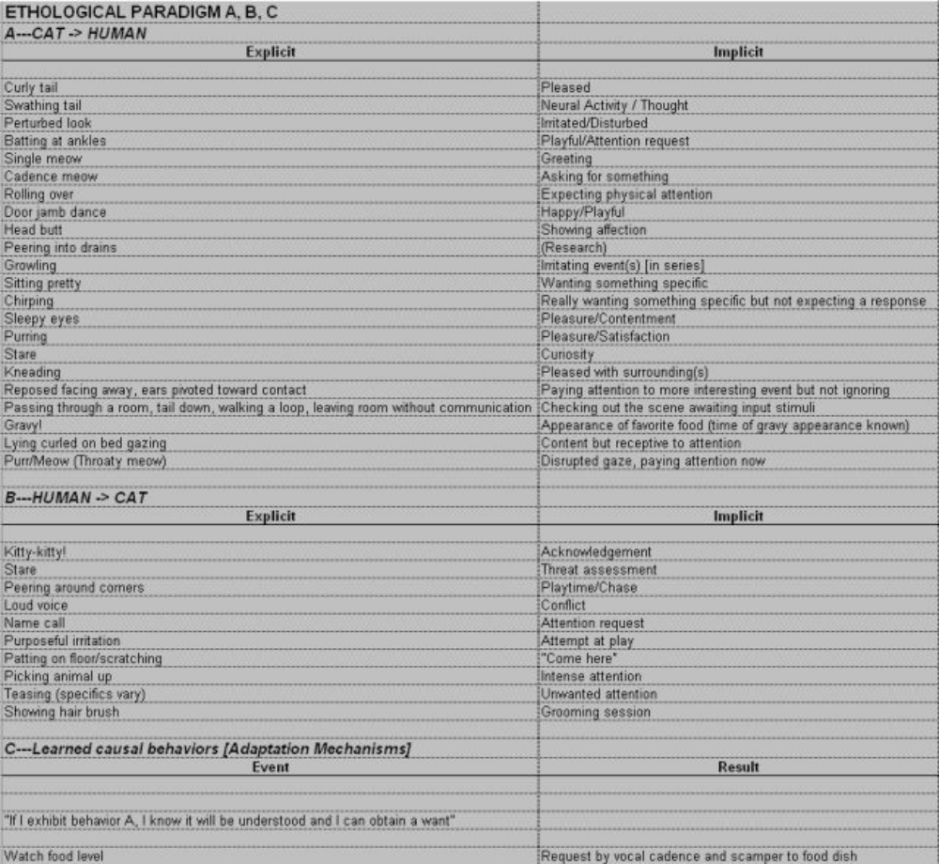
Figure 4: Ethological Paradigms for Aggie
Figure 4 serves as a composite data picture of the ethology of my cat. I have divided the data into three categories, the first two of most importance. What we are looking at here is the communication pathways between myself and the animal. The first compiles the cat to human communication of what she does in action, explicit, and what is interpreted, implicit, by those actions. This categorization will serve to exemplify the communication pathways argument. The mode of communication is less important than realizing communication between a “higher” and “lower” lifeform is taking place. It will aid in understanding that communication occurs between intelligence groups without either quantification and qualification. That it is merely a question of scale alone.
I have left the adaptation mechanisms limited since the more behaviors considered, the more vague the conclusions will become. I have chosen to leave these for the time when I have constructed a physical machine where these mechanisms can be tested more rigorously. In time they will exhibit themselves in a more reliable fashion.
Assaying the Ethological Routine
Once behavior is modeled in the fashion described, behavior routines can be envisioned and tested. An example of such a procedural routine for later test is:
Await companions to awake by choosing sleeping area nearby to them, eyeing their faces for any sign of rising. When believing them to be awake, immediate scamper to area of desire: food, fresh water, and opening of the window shutter for an anticipated sunbeam. Maybe the window will be opened, maybe can sit on the chair to peer out. Sunbeam and shutter opening appears to be a higher priority since, as winter approaches, the window is not opened. So, this points to a want/desire hierarchy; I.E., since food and water are considered plentiful (she is fed and watered at regular, periodic intervals) she desires that which she also wants but the appearance is rare.
The Miscellaneous Ethological Routine
The “she doesn’t know” scenario. She hates being picked up and was trained to give a “kiss” before being let down—by touching her nose to mine. This is a learned adaptation to alter the purposeful outcome. She acts like she hates it, all facial expressions (pursed eyes, ears pulled halfway back) point to this, tail swathing but she purrs nevertheless.
Emergent Causal Behaviors—Ethological Paradigm, [Desire Hierarchy]
When lower needs are regularly met—expected and satisfied from her point of view—a higher need or want is exhibited. For example, the food and water scenario. When rising in the morning, she does not wish for food or water as they will appear when I wake up or soon thereafter (a regular pattern of input from my point of view), she desires the shutters to be opened to advance the sunbeam and the window to be opened in order that she may perch on the window sill for a view of outside.
The Necessity of Discussing of Point of View
Ethological routines cannot be discussed without contextual views. Each agent is autonomous, the totality of the feedback system composed of myself and the subject (cat) and input/output patterns must be read from each viewpoint.

I have covered most of the crucial aspects of a cybernetic organism in the previous two sections. I have covered background information, theory, structure, parameters, and paradigms necessary for an autonomous being. Now we come to the most interesting and factual part of the book—model and experiment. In the section titled “System Architecture” I noted four goals for a successful animae; it is nice to sit and ponder what is theoretically possible, but far more exciting to test the hypotheses proposed. However, we cannot forget the theoretical principles which will serve as a guide for our experiment. But where can we begin to test these principles?
In science, we define a model and an experiment to test our hypotheses. Earlier, I had noted the use of a common housecat as a basis for a model when discussing the concept of volition. This is a good way to devise a model for what will be the ultimate goal, but it is a complex model wrought with complications if one does not understand what the goal might be outside of the body of theory.

